**Exercise 15: Reading Files**

1. Above each line, write out in English what that line does.

**#get the first argument using ARGV.first.**

**file_name = ARGV.first**

**#get the file and assign to the txt variable**

**txt = open(file_name)**

**#Prints the file name within a string**

**puts "Here Your #{file_name}"**

**#prints the content of the file**

**print txt.read**

**#Same Process using $stdin.gets.chomp**

**puts "Enter File again..."**

**#get the file input from user and stores in file_again variable**

**file_again = $stdin.gets.chomp**

**#open a file and stores on txt_again**

**txt_again = open(file_again)**

**#Read the values of file and also prints the content of file**

**print txt_again.read**

1. If you are not sure, ask someone for help or search online. Many times searching for "ruby THING" will find answers to what that THING does in Ruby. Try searching for "ruby open."

**Open method to create a new file object and assigns the file object to the file.**

1. I used the word "commands" here, but commands are also called "functions" and "methods." You will learn about functions and methods later in the book.

**Done.**

1. Get rid of the lines 8-13 where you use gets.chomp and run the script again.

**file_name = ARGV.first**

**txt = open(file_name)**

**puts "Here Your #{file_name}"**

**print txt.read**

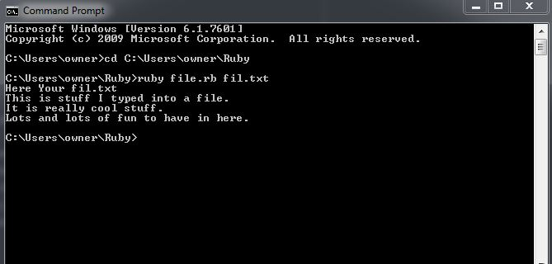

1. Use only gets.chomp and try the script that way. Why is one way of getting the filename better than another?

**puts "Enter your File Name here...."**

**file_name = gets.chomp**

**txt = open(file_name)**

**puts "Here Your #{file_name}"**

**print txt.read**

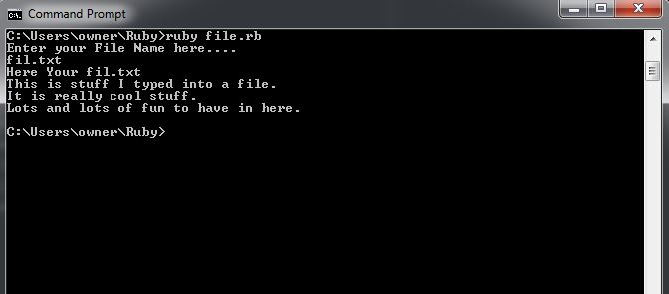

1. Have your script also call close() on the txt and txt_again variables. It's important to close files when you are done with them.

**#get the first argument using ARGV.first.**

**file_name = ARGV.first**

**#get the file and assign to the txt variable**

**txt = open(file_name)**

**#Prints the file name within a string**

**puts "Here Your #{file_name}"**

**#prints the content of the file**

**print txt.read**

**txt.close**

**#Same Process using $stdin.gets.chomp**

**puts "Enter File again..."**

**#get the file input from user and stores in file_again variable**

**file_again = $stdin.gets.chomp**

**#open a file and stores on txt_again**

**txt_again = open(file_again)**

**#Read the values of file and also prints the content of file**

**print txt_again.read**

**txt_again.close**